Great Rhombicosidodecahedron

Definition
# Source: AI Source: Provided by: [Data Path: Persons Table -> ID Column: 1, Name_En Column: Motasem Essam] -> From: [ChatGPT] on [7/25/2026]
The Great Rhombicosidodecahedron, also known as the Truncated Icosidodecahedron, is a convex Archimedean solid composed of 62 regular polygonal faces: 30 squares, 20 regular hexagons, and 12 regular decagons.
It has 120 vertices and 180 edges. At every vertex, one square, one hexagon, and one decagon meet in the same arrangement.

Geometric Structure
# Source: AI Source: Provided by: [Data Path: Persons Table -> ID Column: 1, Name_En Column: Motasem Essam] -> From: [ChatGPT] on [7/25/2026]
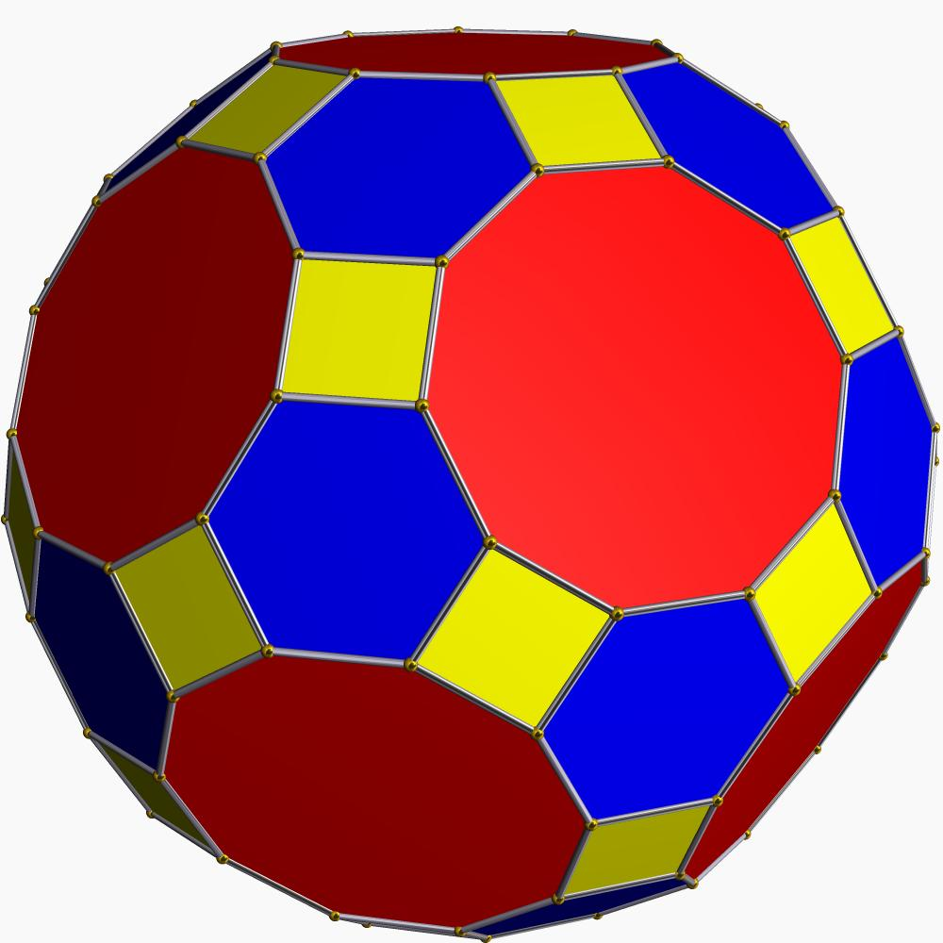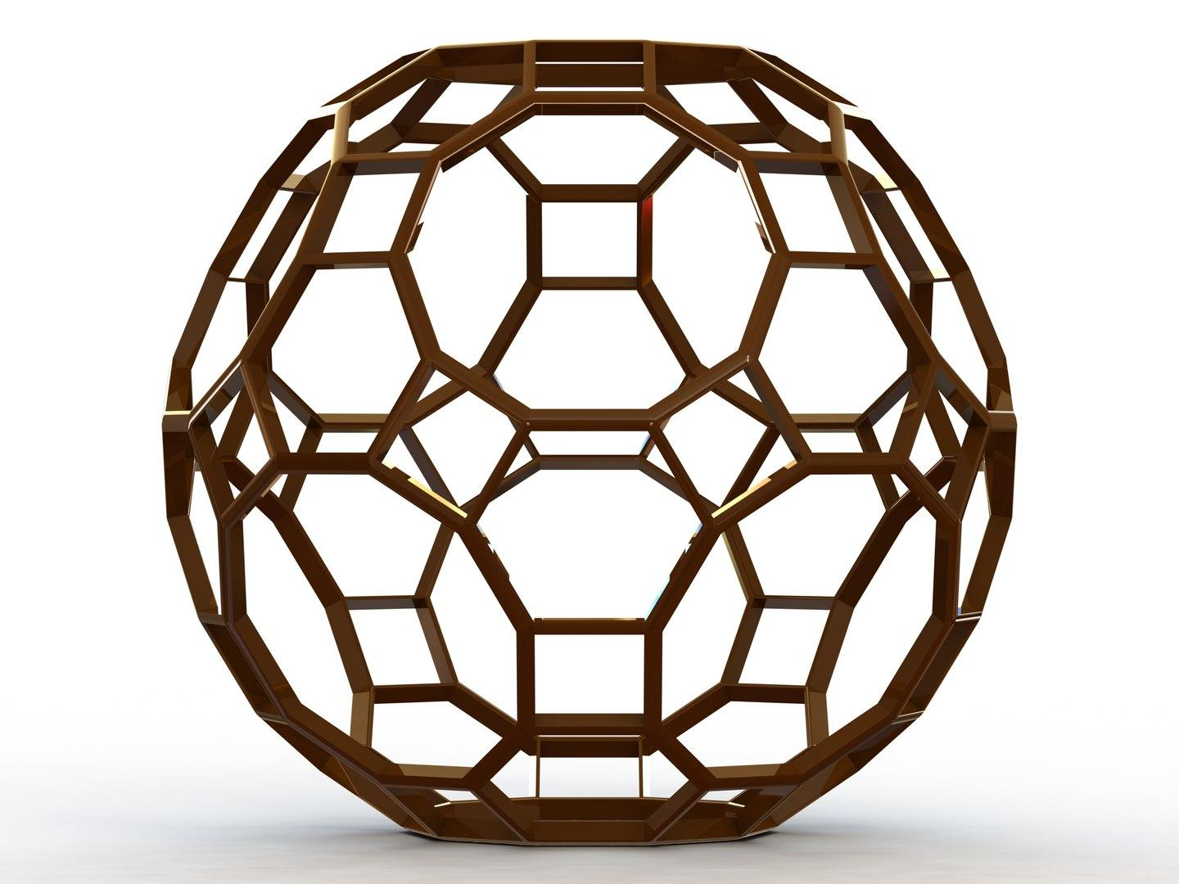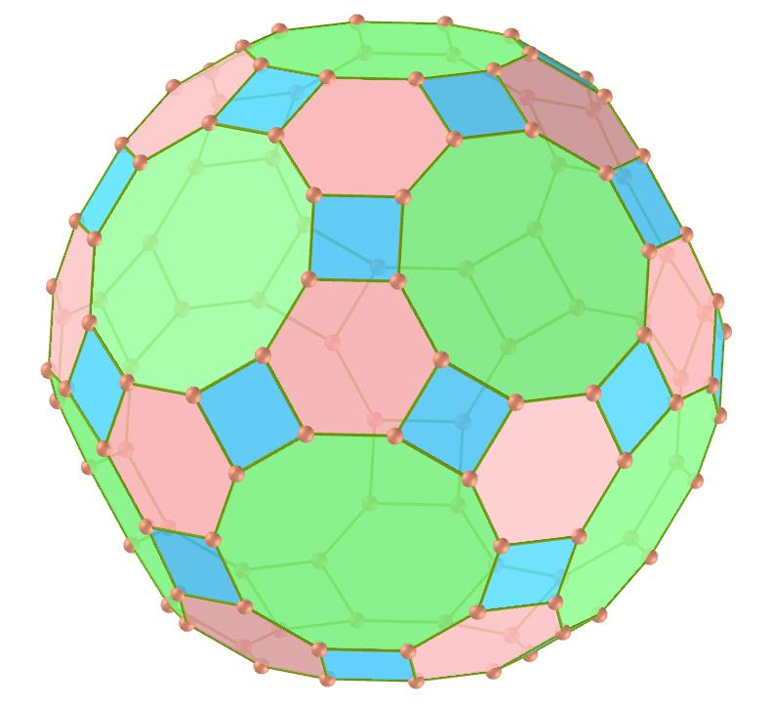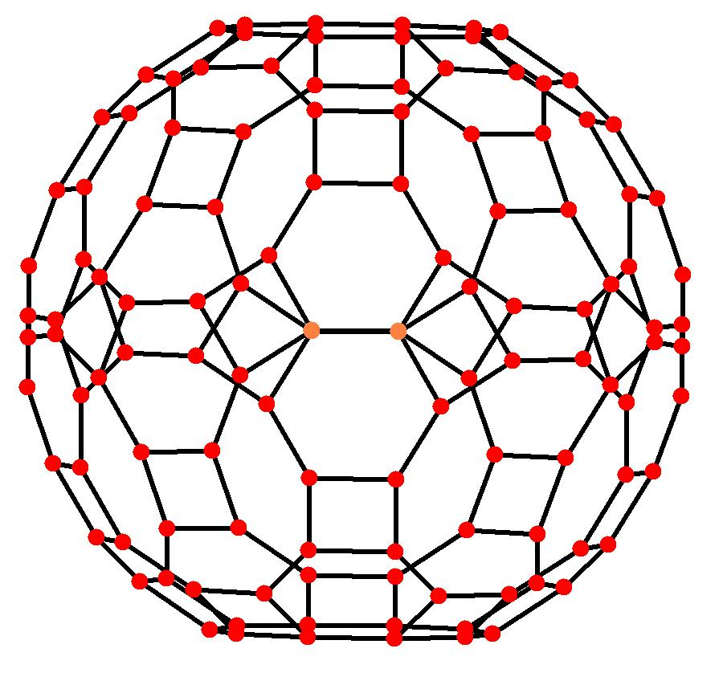
The solid consists of three types of regular polygonal faces:
- 30 Square Faces: Regular squares.
- 20 Hexagonal Faces: Regular hexagons.
- 12 Decagonal Faces: Regular decagons.
Its polygonal faces are arranged uniformly around every vertex.

Face Composition
# Source: AI Source: Provided by: [Data Path: Persons Table -> ID Column: 1, Name_En Column: Motasem Essam] -> From: [ChatGPT] on [7/25/2026]
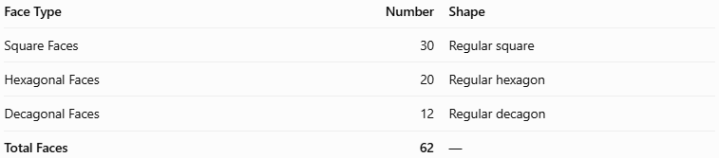
Face Type | Number | Shape
Square Faces | 30 | Regular square
Hexagonal Faces | 20 | Regular hexagon
Decagonal Faces | 12 | Regular decagon
Total Faces | 62 | —

Mathematical Properties
# Source: AI Source: Provided by: [Data Path: Persons Table -> ID Column: 1, Name_En Column: Motasem Essam] -> From: [ChatGPT] on [7/25/2026]
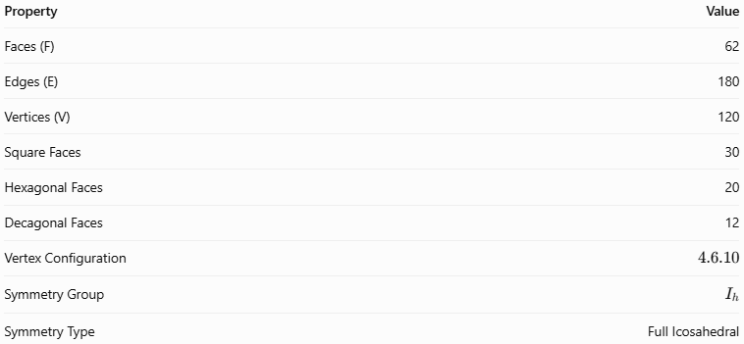
Property | Value
Faces (F) | 62
Edges (E) | 180
Vertices (V) | 120
Square Faces | 30
Hexagonal Faces | 20
Decagonal Faces | 12
Vertex Configuration | $$4.6.10$$
Symmetry Group | $$I_{h}$$
Symmetry Type | Full Icosahedral
Euler's Formula:
$$V-E+F=2$$
$$120-180+62=2$$
Surface Area:
For edge length $a$:
$$A=30(1+\sqrt{3}+\sqrt{5+2\sqrt{5}})a^{2}$$
Approximately:
$$A≈174.292a^{2}$$
Volume:
For edge length $a$:
$$V≈206.803a^{3}$$
The vertex configuration $4.6.10$ means that one square, one hexagon, and one decagon meet at every vertex.

Geometric Characteristics
# Source: AI Source: Provided by: [Data Path: Persons Table -> ID Column: 1, Name_En Column: Motasem Essam] -> From: [ChatGPT] on [7/25/2026]
- It is a convex Archimedean solid.
- It is also known as the Truncated Icosidodecahedron.
- All faces are regular polygons.
- All edges have equal length.
- Every vertex has the same arrangement of faces.
- It has full icosahedral symmetry, represented by $I_{h}$.
- It contains three different polygon types: squares, hexagons, and decagons.
- Its dual polyhedron is the Disdyakis Triacontahedron, also called the Hexakis Icosahedron.

Geometric Construction
# Source: AI Source: Provided by: [Data Path: Persons Table -> ID Column: 1, Name_En Column: Motasem Essam] -> From: [ChatGPT] on [7/25/2026]
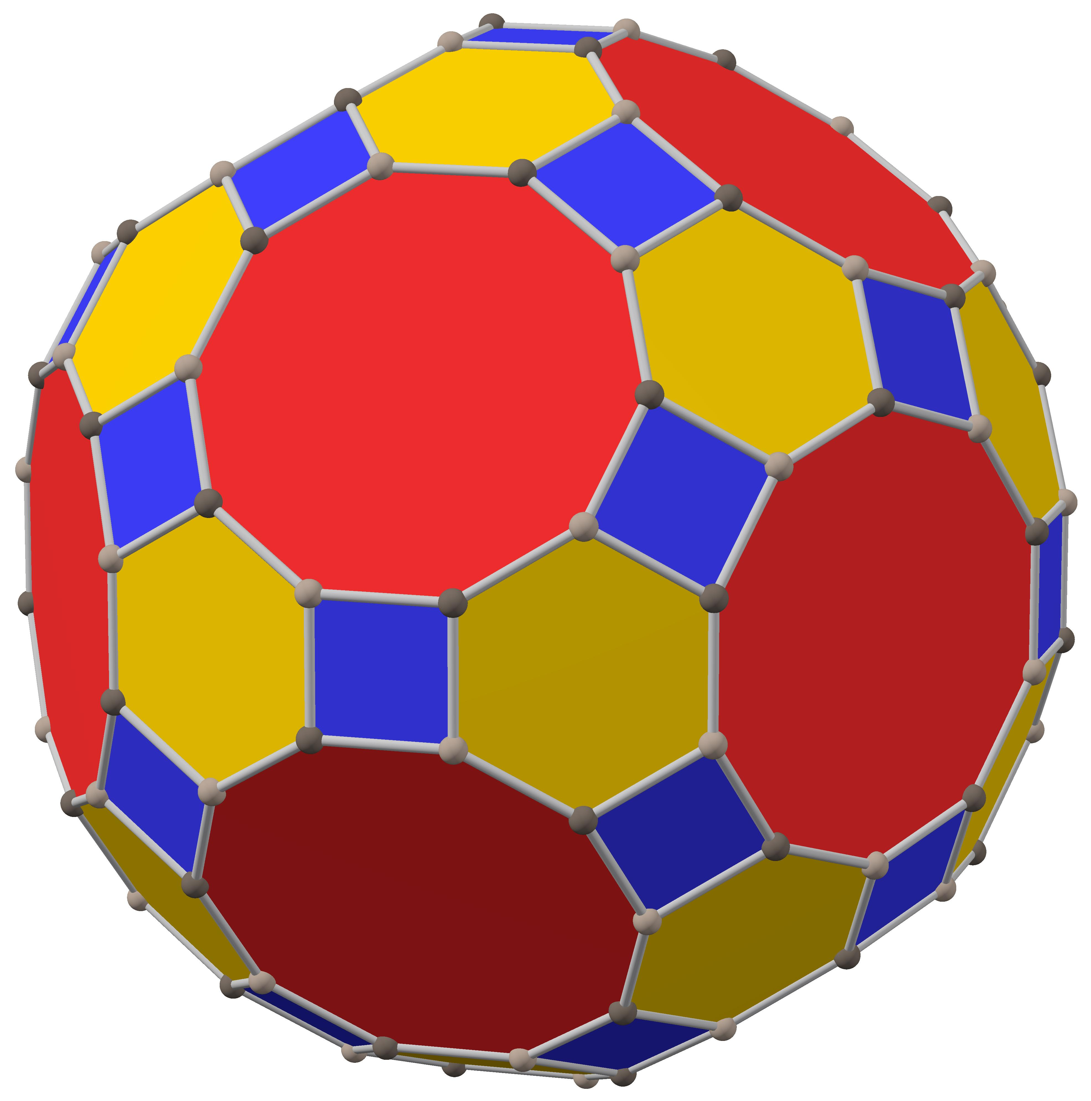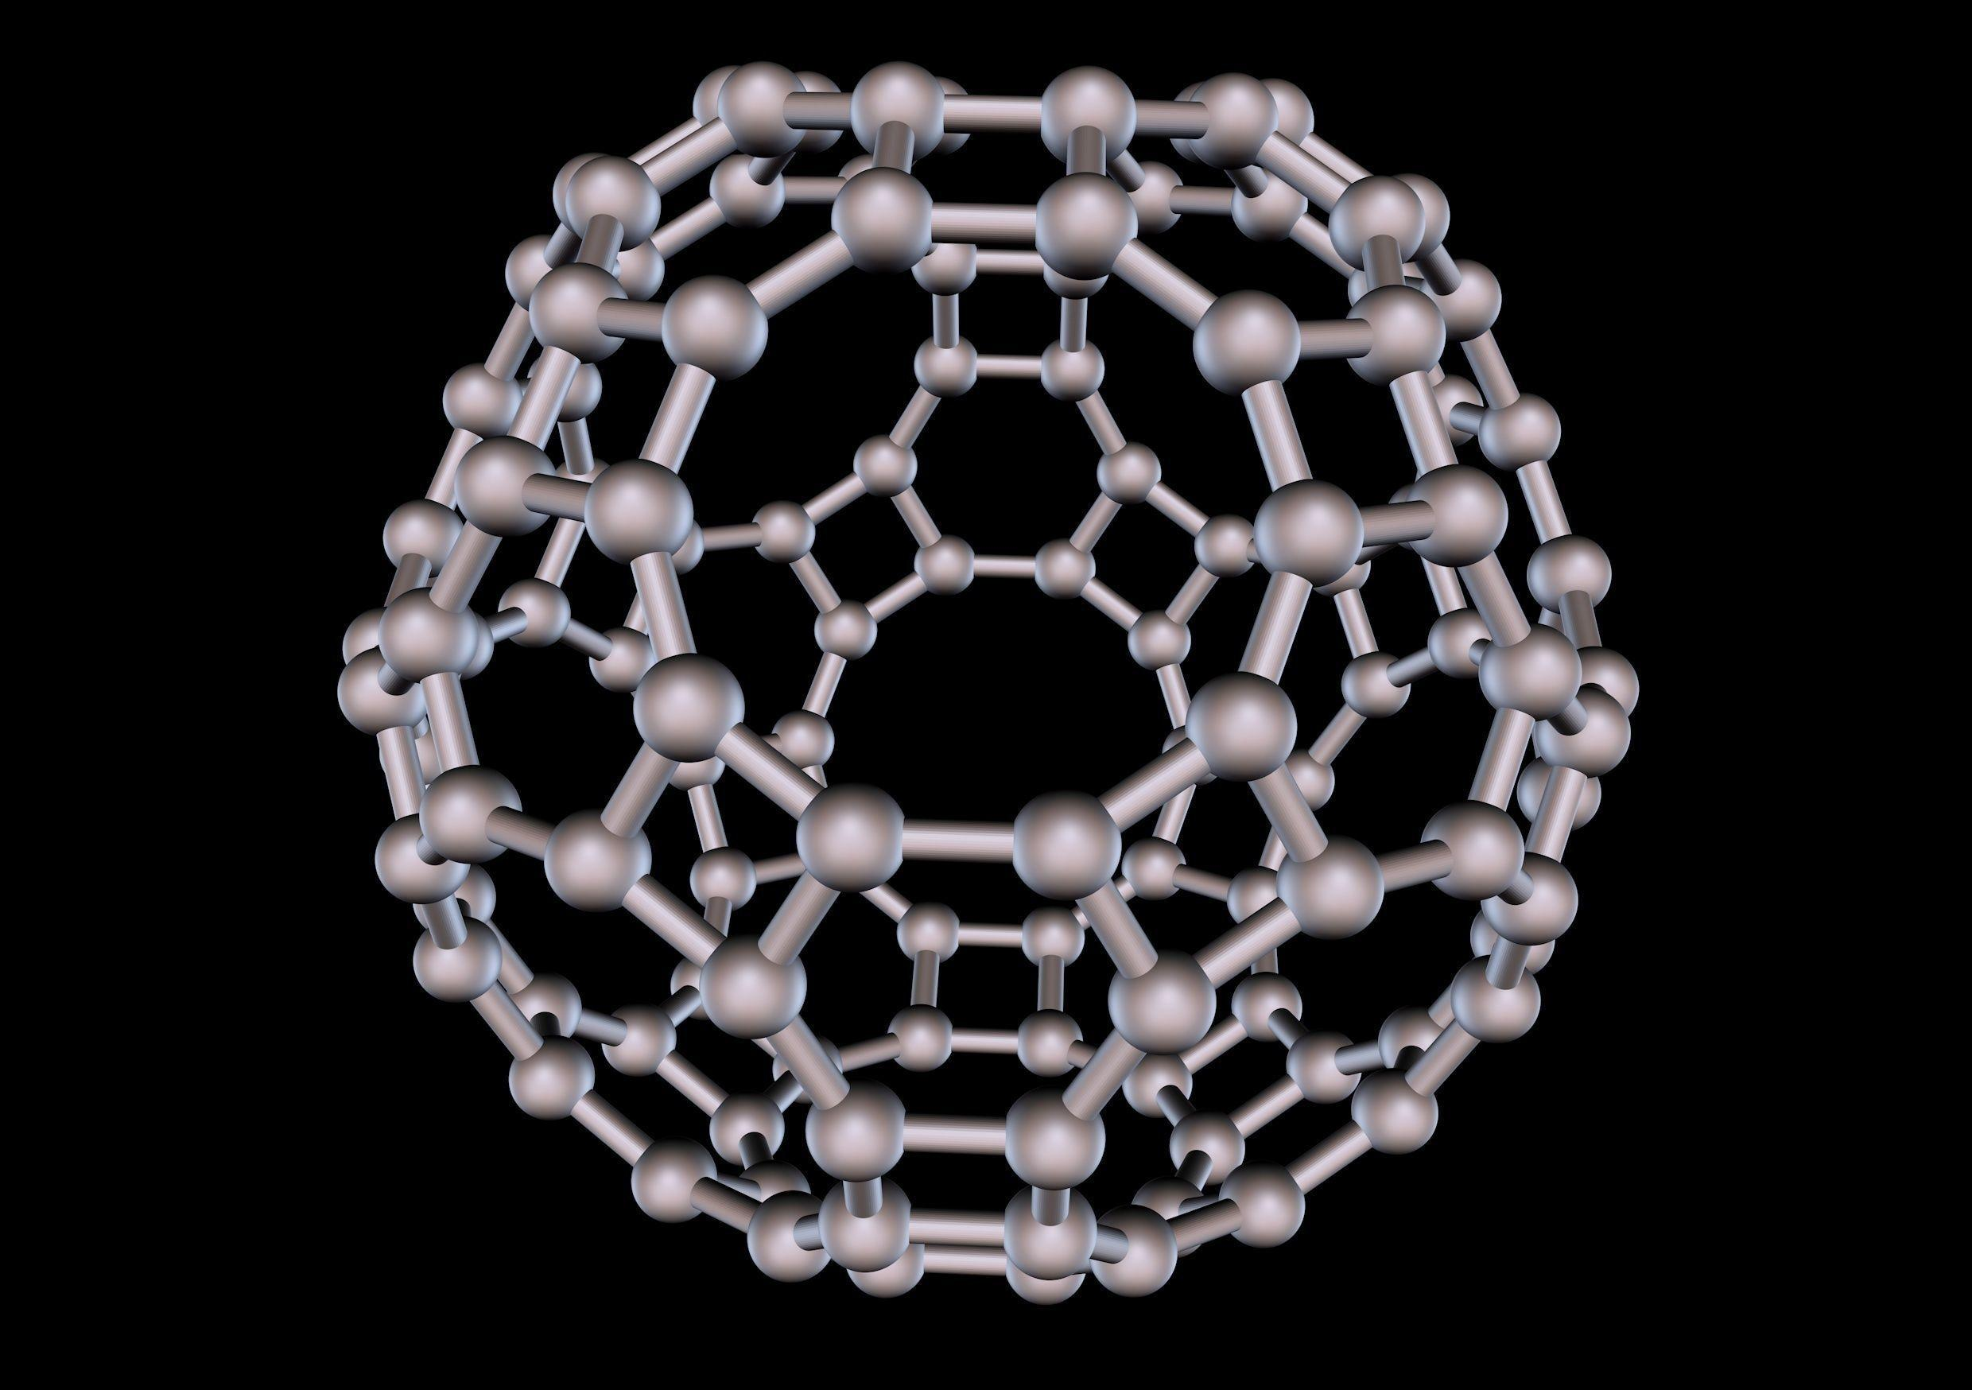
The Great Rhombicosidodecahedron can be constructed by truncating the vertices of an Icosidodecahedron.
The construction involves:
- Begin with an Icosidodecahedron, which has 20 triangular faces and 12 pentagonal faces.
- Truncate its 30 vertices.
- The original triangular faces become 20 regular hexagons.
- The original pentagonal faces become 12 regular decagons.
- The truncated vertices create 30 new square faces.
- Arrange the truncation so that all resulting edges have equal lengths.
The resulting solid contains 30 squares, 20 hexagons, and 12 decagons.

Related Geometric Solids
# Source: AI Source: Provided by: [Data Path: Persons Table -> ID Column: 1, Name_En Column: Motasem Essam] -> From: [ChatGPT] on [7/25/2026]
Icosidodecahedron
The Archimedean solid from which the Great Rhombicosidodecahedron can be constructed by truncating its vertices.
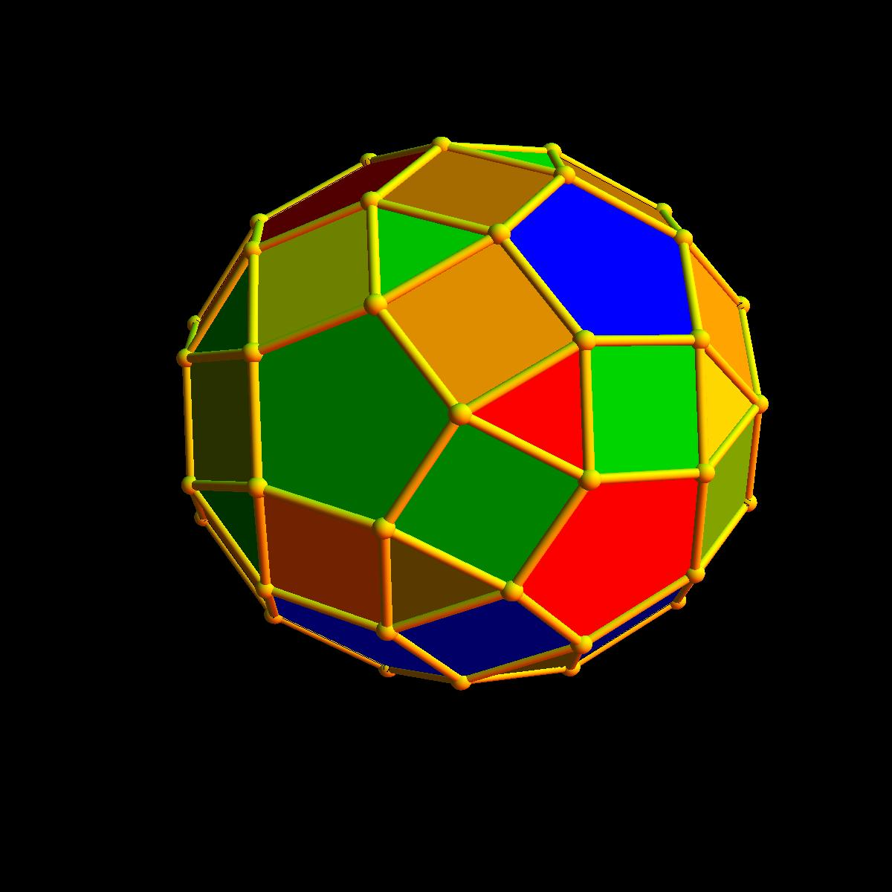
Small Rhombicosidodecahedron
A different Archimedean solid composed of 20 triangles, 30 squares, and 12 pentagons.
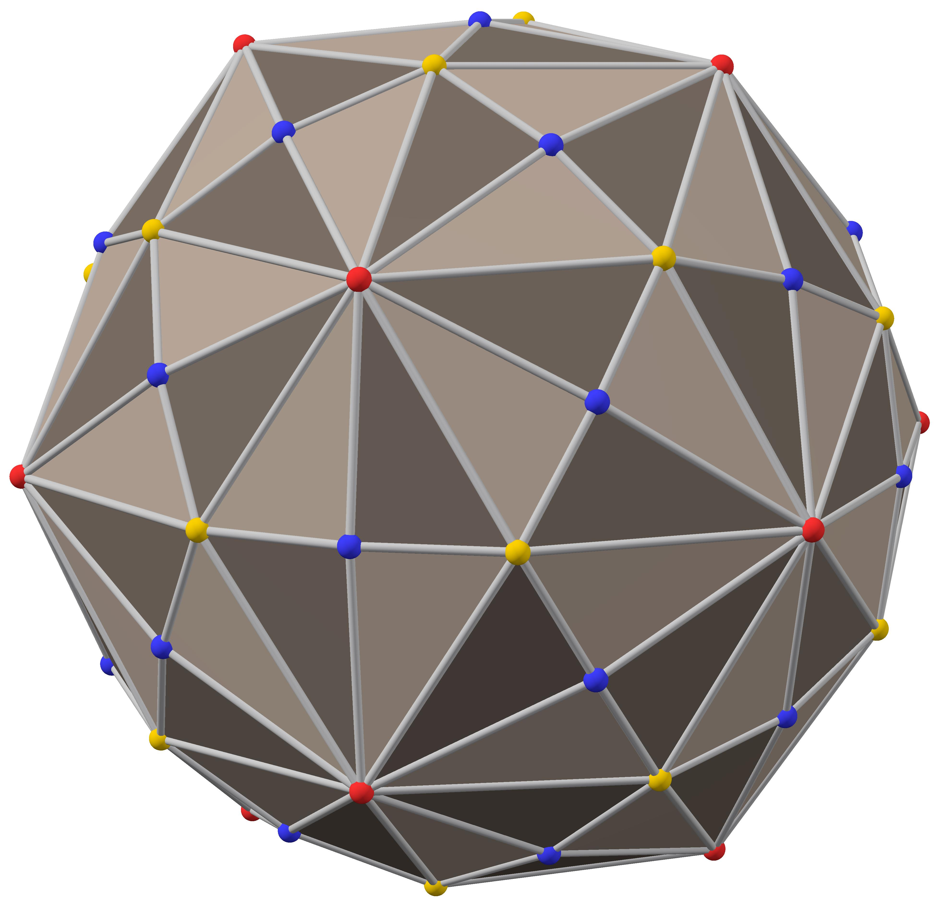
Disdyakis Triacontahedron
The dual polyhedron of the Great Rhombicosidodecahedron, also called the Hexakis Icosahedron.

Construction of Great Rhombicosidodecahedron

Geometric Instruments Used
# Source: AI Source: Provided by: [Data Path: Persons Table -> ID Column: 1, Name_En Column: Motasem Essam] -> From: [ChatGPT] on [7/25/2026]
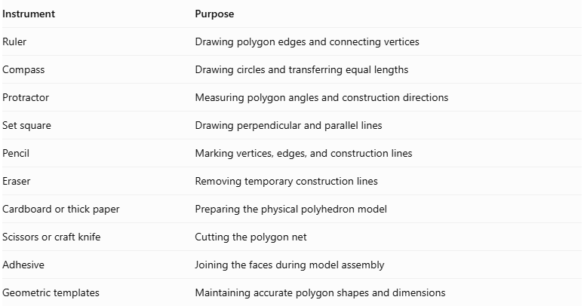
Instrument | Purpose
Ruler | Drawing polygon edges and connecting vertices
Compass | Drawing circles and transferring equal lengths
Protractor | Measuring polygon angles and construction directions
Set square | Drawing perpendicular and parallel lines
Pencil | Marking vertices, edges, and construction lines
Eraser | Removing temporary construction lines
Cardboard or thick paper | Preparing the physical polyhedron model
Scissors or craft knife | Cutting the polygon net
Adhesive | Joining the faces during model assembly
Geometric templates | Maintaining accurate polygon shapes and dimensions

Instrument-Based Construction Procedures

Establishing the Common Edge Length
# Source: AI Source: Provided by: [Data Path: Persons Table -> ID Column: 1, Name_En Column: Motasem Essam] -> From: [ChatGPT] on [7/25/2026]
- Choose a convenient edge length $a$.
- Draw a reference line segment using a ruler.
- Use a compass to transfer the same length to the remaining polygon constructions.
- Keep this edge length consistent for every square, hexagon, and decagon.
All 180 edges of the uniform solid have equal length.

Constructing the Square Faces
# Source: AI Source: Provided by: [Data Path: Persons Table -> ID Column: 1, Name_En Column: Motasem Essam] -> From: [ChatGPT] on [7/25/2026]
- Draw a reference line segment $AB=a$.
- Construct a perpendicular line at $A$.
- Mark $AD=a$.
- Construct the remaining perpendicular sides.
- Complete the square $ABCD$.
- Verify that all four sides are equal and all interior angles are ${90}^{°}$.
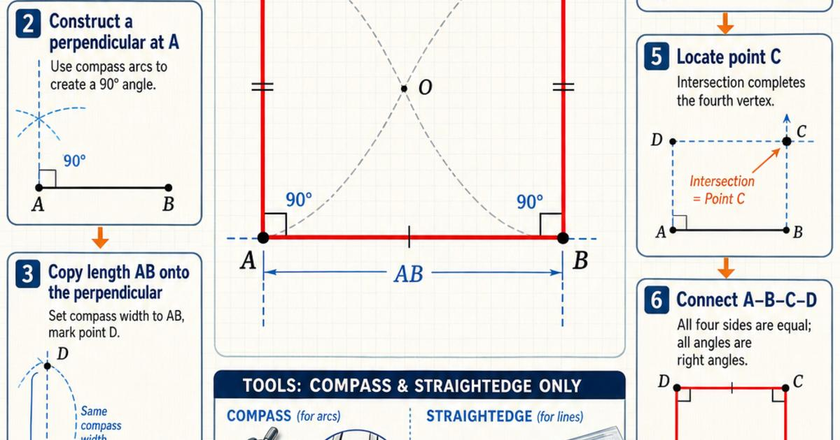
Repeat this construction to prepare 30 square faces.

Constructing the Regular Hexagonal Faces
# Source: AI Source: Provided by: [Data Path: Persons Table -> ID Column: 1, Name_En Column: Motasem Essam] -> From: [ChatGPT] on [7/25/2026]
- Draw a circle using a compass with radius $a$.
- Mark a starting point on its circumference.
- Keep the compass opening unchanged.
- Step the radius around the circumference to mark six equally spaced vertices.
- Connect consecutive vertices using a ruler.
- Verify that the six sides are equal and the interior angles are ${120}^{°}$.
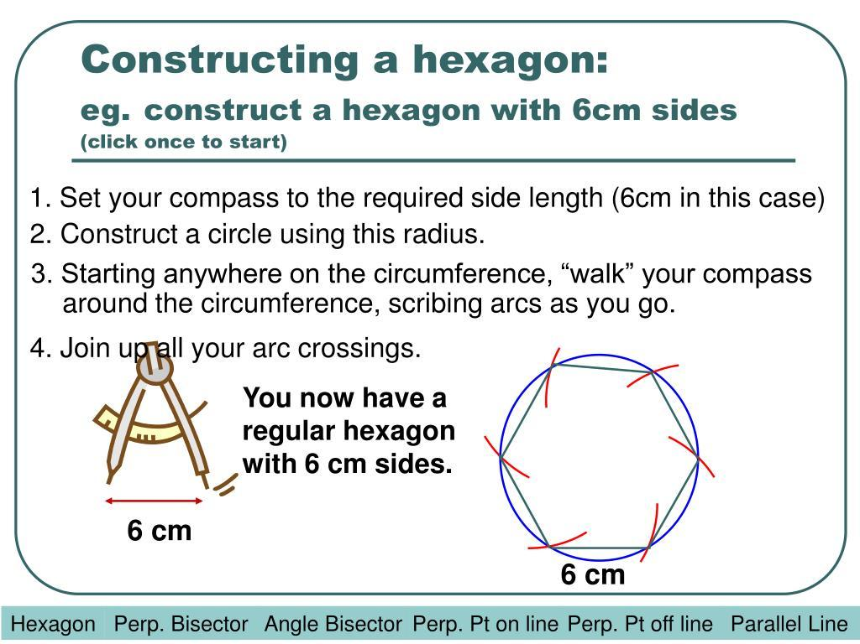
Repeat this construction to prepare 20 regular hexagonal faces.

Constructing the Regular Decagonal Faces
# Source: AI Source: Provided by: [Data Path: Persons Table -> ID Column: 1, Name_En Column: Motasem Essam] -> From: [ChatGPT] on [7/25/2026]
- Draw a circle using a compass.
- Mark its center.
- Divide the circumference into ten equal angular sections.
- Mark the ten vertices.
- Connect consecutive vertices using a ruler.
- Verify that the ten sides are equal and the interior angles are ${144}^{°}$.
The central angle between consecutive vertices is:
$$θ=\frac{{360}^{°}}{10}={36}^{°}$$
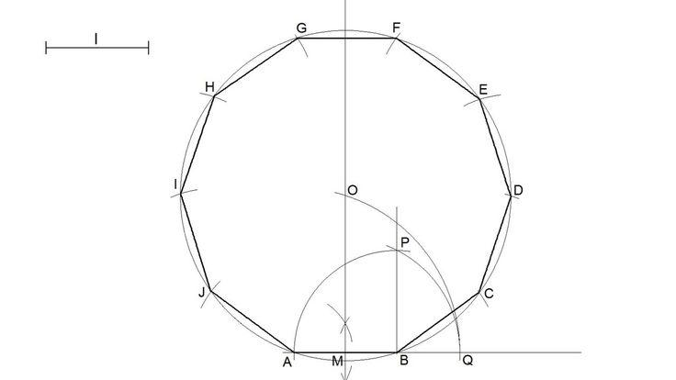
Repeat this construction to prepare 12 regular decagonal faces.

Establishing the Vertex Arrangement
# Source: AI Source: Provided by: [Data Path: Persons Table -> ID Column: 1, Name_En Column: Motasem Essam] -> From: [ChatGPT] on [7/25/2026]
The Great Rhombicosidodecahedron uses the same arrangement of faces around every vertex.
- Select one square face as the reference face.
- Identify one of its vertices.
- Position a regular hexagonal face along one adjacent edge.
- Position a regular decagonal face along the other required adjacent edge.
- Arrange the three faces so that they meet at the same vertex.
- Check their interior angles:
$${90}^{°}+{120}^{°}+{144}^{°}={354}^{°}$$
- Repeat the required arrangement throughout the model while preserving equal edge lengths and the correct face adjacency.

Constructing the Complete Polyhedron
# Source: AI Source: Provided by: [Data Path: Persons Table -> ID Column: 1, Name_En Column: Motasem Essam] -> From: [ChatGPT] on [7/25/2026]
- Use the reference net of the Great Rhombicosidodecahedron.
- Transfer the net onto cardboard or thick paper.
- Preserve the exact number and arrangement of all polygonal faces.
- Cut around the outer boundary of the net.
- Fold along the shared edges.
- Join the matching edges carefully.
- Check that all faces close into one solid without gaps or unintended overlaps.
- Verify the final face inventory:
- 30 squares
- 20 regular hexagons
- 12 regular decagons
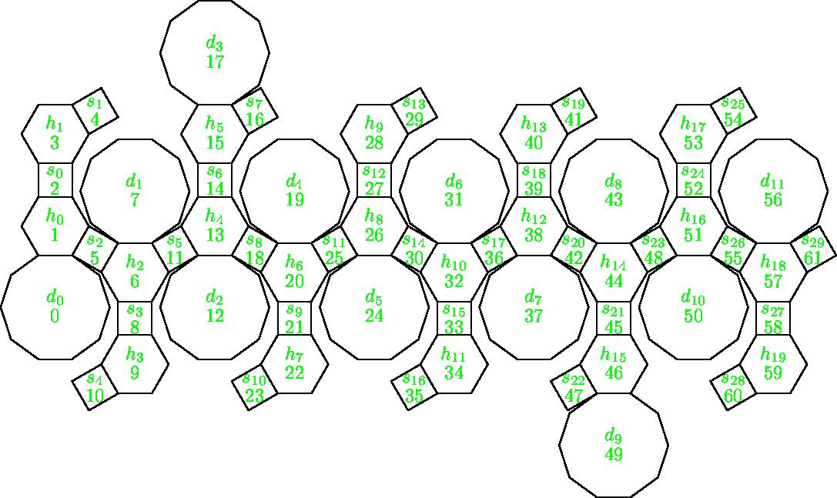
Construction reference: Wolfram MathWorld provides a dedicated net for this solid, suitable as a reference for arranging the faces.

Key Points
# Source: AI Source: Provided by: [Data Path: Persons Table -> ID Column: 1, Name_En Column: Motasem Essam] -> From: [ChatGPT] on [7/25/2026]
- The Great Rhombicosidodecahedron is one of the 13 classical Archimedean solids.
- It has 62 faces, 180 edges, and 120 vertices.
- Its faces consist of 30 squares, 20 hexagons, and 12 decagons.
- Its vertex configuration is $4.6.10$.
- It has full icosahedral symmetry $I_{h}$.
- It can be constructed by truncating the vertices of an Icosidodecahedron.
- Its dual is the Disdyakis Triacontahedron.
- It is also known as the Truncated Icosidodecahedron.
- It should not be confused with the Small Rhombicosidodecahedron.

Main Classification
# Source: AI Source: Provided by: [Data Path: Persons Table -> ID Column: 1, Name_En Column: Motasem Essam] -> From: [ChatGPT] on [7/25/2026]
Solid Geometry
└── Types of Solids
└── Great Rhombicosidodecahedron
├── Square Faces
├── Hexagonal Faces
├── Decagonal Faces
├── Vertices
├── Edges
└── Geometric Properties

Conclusion
# Source: AI Source: Provided by: [Data Path: Persons Table -> ID Column: 1, Name_En Column: Motasem Essam] -> From: [ChatGPT] on [7/25/2026]
The Great Rhombicosidodecahedron is a convex Archimedean solid characterized by its combination of squares, hexagons, and decagons. Its uniform vertex arrangement, icosahedral symmetry, and relationship to the Icosidodecahedron make it an important example of a complex uniform polyhedron.

